Q1 | Create a table named MusicPlaylist with columns: id, song_name, artist, genre, and duration. Insert at least 5 records representing songs from your favorite Spotify playlist, then write a SELECT statement to retrieve all columns for all songs.
Code | CREATE TABLE MusicPlaylist(  id INT PRIMARY KEY,  song_name VARCHAR(100),  artist VARCHAR(100),  genre VARCHAR(50),  duration INT  );  INSERT INTO MusicPlaylist (id, song_name, artist, genre, duration)  VALUES  (1, 'Shape Of You', 'Ed Sheeran', 'Pop', 424),  (2, 'Born to Shine', 'Diljit Dosanjh', 'Punjabi', 338),  (3, 'Phir Kabhi', 'Arijit Singh', 'Bollywood', 335),  (4, 'Shayad', 'Arijit Singh', 'Romantic', 310),  (5, 'Perfect', 'Ed Sheeran', 'Pop', 442);  SELECT * FROM musicplaylist;
Output | 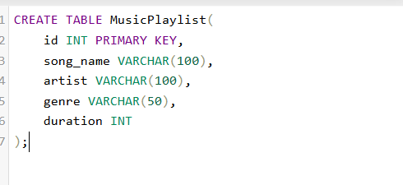  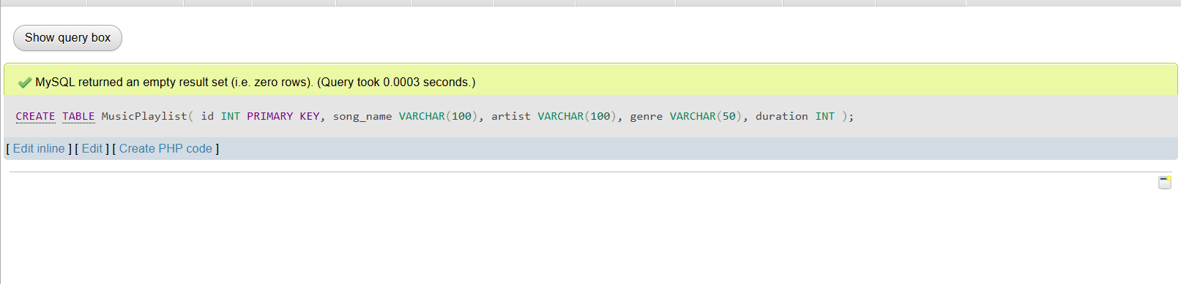  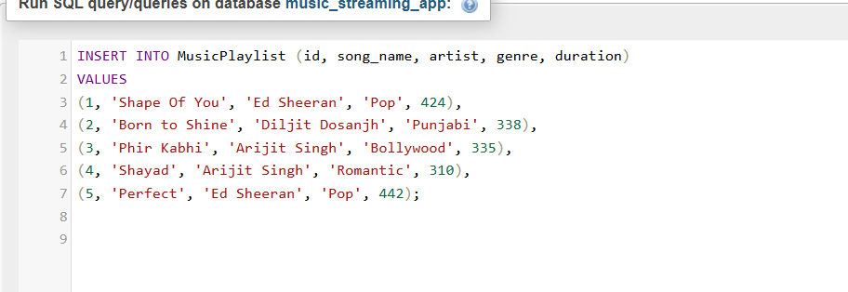  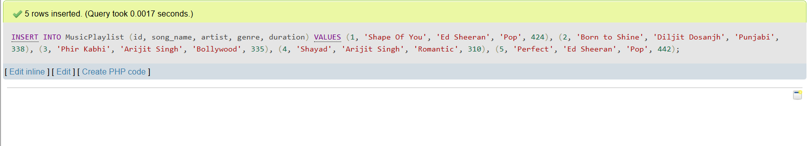  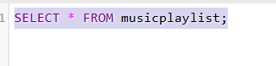  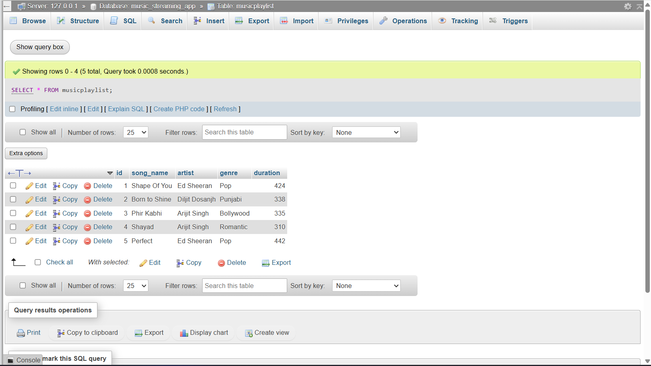

Q2 | Write a SQL query to display only the song_name and artist columns from the MusicPlaylist table, showing just the first 3 records using the LIMIT keyword.
Code | SELECT song_name, artist  FROM MusicPlaylist  LIMIT 3;
Output | 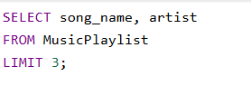  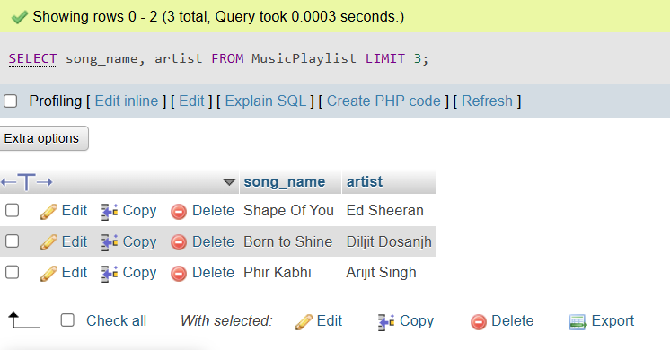

Q3 | Suppose you have a table named FoodOrders with columns: id, restaurant, food_item, and order_date. Write a SQL query to list all unique restaurant names where you have placed orders, using the DISTINCT keyword.
Code | Step1: CREATE TABLE Foodorders(  id INT PRIMARY KEY,  restaurant VARCHAR(100),  food_item VARCHAR(100),  order_date DATE  );  Step2: INSERT INTO foodorders (id, restaurant, food_item, order_date)  VALUES  (1, 'Dominos', 'Pizza', '2026-06-01'),  (2, 'McDonalds', 'Burger', '2026-06-02'),  (3, 'Dominos', 'Garlic Bread', '2026-06-03'),  (4, 'KFC', 'Chicken Bucket', '2026-06-04'),  (5, 'McDonalds', 'Fries', '2026-06-05');  Step3: SELECT DISTINCT restaurant  FROM FoodOrders;
Output | 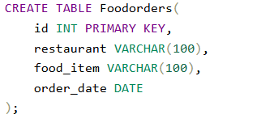  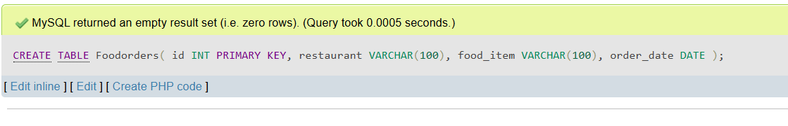  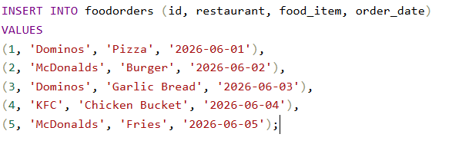  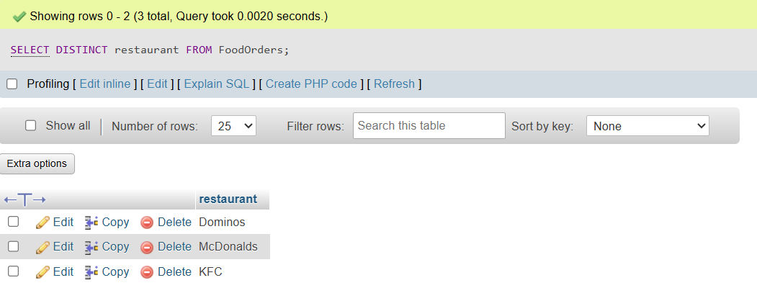  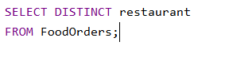  

Q4 | Write a SQL query on the FoodOrders table to select food_item as 'Dish' and order_date as 'Date Ordered', displaying only these two columns with the column aliases in the output.
Code | SELECT food_item AS 'Dish',  order_date AS 'Date Ordered'  FROM FoodOrders;
Output | 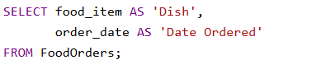  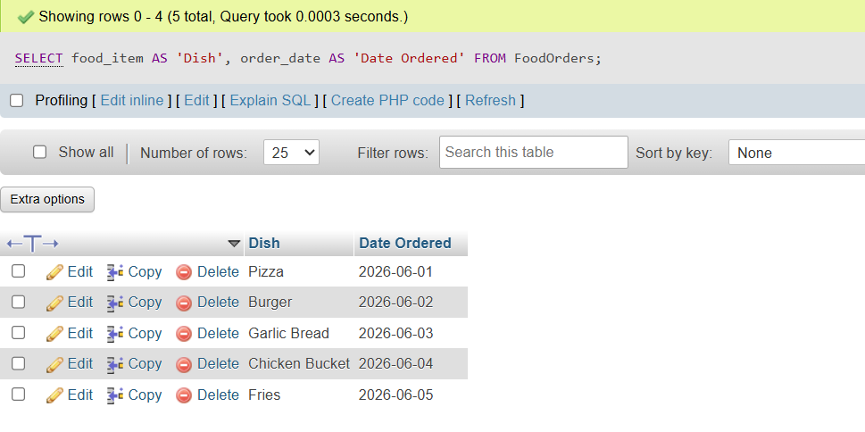

Q5 | You tried running this query: SELECT DISTINCT food_item, restaurant FROM FoodOrders LIMIT 2, but it returns an error or doesn't work as expected. Identify and fix the mistake in the query.<br><br><em><strong>Hint:</strong> Check the correct placement and usage of the LIMIT keyword in SQL syntax.</em>
Code | SELECT food_item, restaurant  FROM FoodOrders  LIMIT 2;
Output | 